
High School
INTERNET Resources
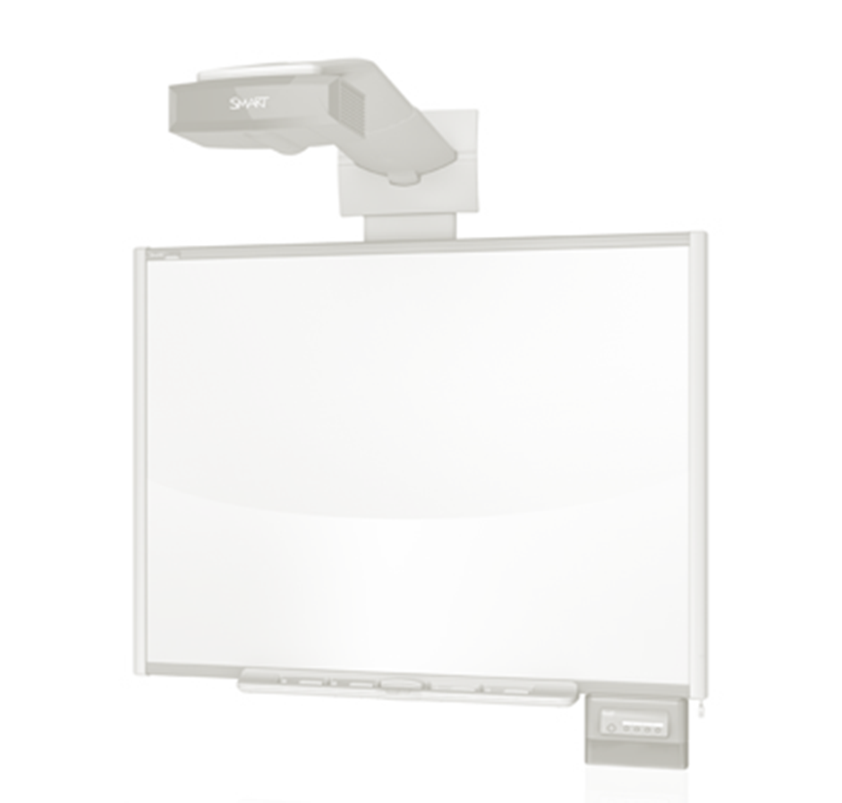

English Language Arts
http://www.bbc.co.uk/history/interactive/timelines/language_timeline/index_embed.shtml
Grammar Bytes
http://www.chompchomp.com

Chemistry
Jefferson Lab
http://education.jlab.org/indexpages/elementgames.php
WebElements
http://www.webelements.com
Periodic Table of the Elements Los Alamos National Laboratory
http://periodic.lana.gov/index.shtml
CSI
http://forensics.rice.edu
New York Times Science
http://www.nytimes.com/pages/science/index.html

Biology
Virtual Labs
http://www2.edc.org/weblabs/WebLabDirectory1.html
Possible test questions-ACT
http://www.actstudent.org/sampletest/science/sci_03.html
Reproduction Video
http://www.pbs.org/teachers/connect/resources/225/preview
Science articles geared for students
http://www.sciencewsforkids.org
Physical Education
http://pecentral.org/
Fine Arts
http://www.abcgallery.com
http://www.metmuseum.org
http://new.myfonts.com

